Asia-China-Coin-Bridge leaf design

size : length 3.9 in., height 1.5 in., 18gm. Not in Coole 1976 v.5.

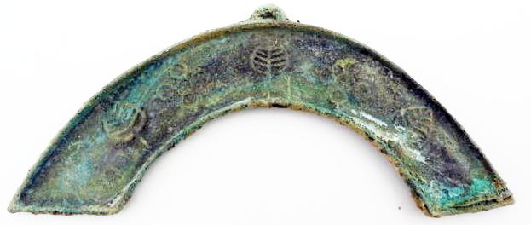

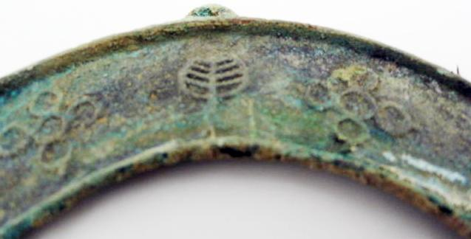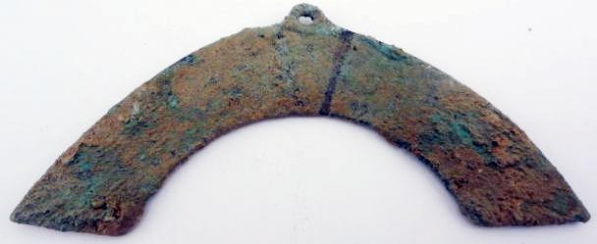

Order details Printer friendly page

Sold by

[lengxue](http://myworld.ebay.com/lengxue) ( [28](http://feedback.ebay.com/ws/eBayISAPI.dll?ViewFeedback&userid=lengxue)  )

+ Show additional actions

Delivery package 1 of 1

Estimated delivery Thursday, Jan 9, 2014 - Friday, Jan 17, 2014

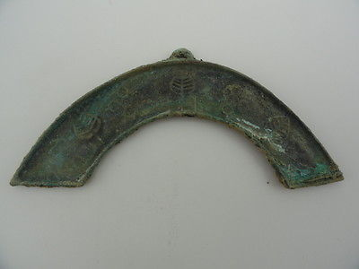

[Artwork Chinese bronze sculpture, bridge, carved tools of the trade,rusty](http://www.ebay.com/itm/141147491326)

Item price

$4.99

Quantity

1

Item number

141147491326

Shipping service

ePacket delivery from China

[Leave feedback](http://feedback.ebay.com/ws/eBayISAPI.dll?LeaveFeedbackShow&useridfrom=802-867&useridto=lengxue&item=141147491326&transactid=0) [Contact seller](http://contact.ebay.com/ws/eBayISAPI.dll?FindAnswers&frm=3998&iid=141147491326&redirect=0&requested=lengxue) [Return item](http://return.ebay.com/ws/eBayISAPI.dll?ResolveReturn&eventName=viewSelectedItem&TransactionId=0&ItemId=141147491326)

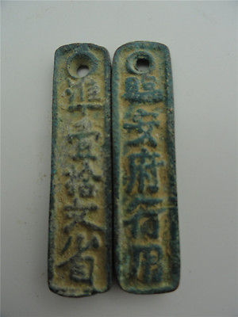

[China Tools of the trade,the southern song dynasty period,bronze sculptures](http://www.ebay.com/itm/141147498491)

Item price

$5.99

Quantity

1

Item number

141147498491

Shipping service

ePacket delivery from China

[Leave feedback](http://feedback.ebay.com/ws/eBayISAPI.dll?LeaveFeedbackShow&useridfrom=802-867&useridto=lengxue&item=141147498491&transactid=0) [Contact seller](http://contact.ebay.com/ws/eBayISAPI.dll?FindAnswers&frm=3998&iid=141147498491&redirect=0&requested=lengxue) [Return item](http://return.ebay.com/ws/eBayISAPI.dll?ResolveReturn&eventName=viewSelectedItem&TransactionId=0&ItemId=141147498491)

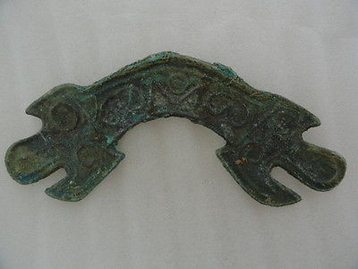

[Oriental Asian Chinese style Artwork bridge tools of the trade Tiger statue](http://www.ebay.com/itm/141147652864)

Item price

$4.99

Quantity

1

Item number

141147652864

Shipping service

ePacket delivery from China

[Leave feedback](http://feedback.ebay.com/ws/eBayISAPI.dll?LeaveFeedbackShow&useridfrom=802-867&useridto=lengxue&item=141147652864&transactid=0) [Contact seller](http://contact.ebay.com/ws/eBayISAPI.dll?FindAnswers&frm=3998&iid=141147652864&redirect=0&requested=lengxue) [Return item](http://return.ebay.com/ws/eBayISAPI.dll?ResolveReturn&eventName=viewSelectedItem&TransactionId=0&ItemId=141147652864)

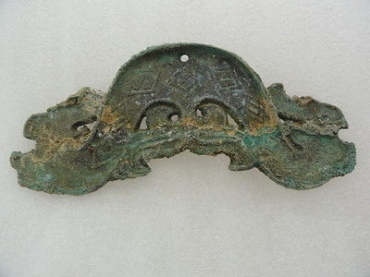

[Oriental Asian Chinese Vintage style tools of the trade pendant Dragon-head](http://www.ebay.com/itm/141147655133)

Item price

$4.99

Quantity

1

Item number

141147655133

Shipping service

ePacket delivery from China

[Leave feedback](http://feedback.ebay.com/ws/eBayISAPI.dll?LeaveFeedbackShow&useridfrom=802-867&useridto=lengxue&item=141147655133&transactid=0) [Contact seller](http://contact.ebay.com/ws/eBayISAPI.dll?FindAnswers&frm=3998&iid=141147655133&redirect=0&requested=lengxue) [Return item](http://return.ebay.com/ws/eBayISAPI.dll?ResolveReturn&eventName=viewSelectedItem&TransactionId=0&ItemId=141147655133)

### Shipping address

Ralph J Coffman Jr  
149 Atlantic Ave   
Swampscott MA 01907-2427  
United States

Phone number  
781 584 7091

### Order total

Subtotal $20.96

Shipping Free

#### Total

## $20.96

[View PayPal transaction](http://payments.ebay.com/ws1/eBayISAPI.dll?IntermediateResolutionInfo&itemid=0&transId=0&pn=UnifiedCheckoutSummaryRedirect2PP&qs=itemid%3D0%26transId%3D0%26buyerorseller%3D0%26)

### Order information

Order placed on  
Monday, Dec 30, 2013

Having a problem with this purchase?  
[Resolve problem](http://res.ebay.com/ws/eBayISAPI.dll?ResolutionCenter)

Payment method   
PayPal

Payment date  
Monday, Dec 30, 2013